**SDK Programming Guide**

Latest version 1.9.0.0

1. Calling program

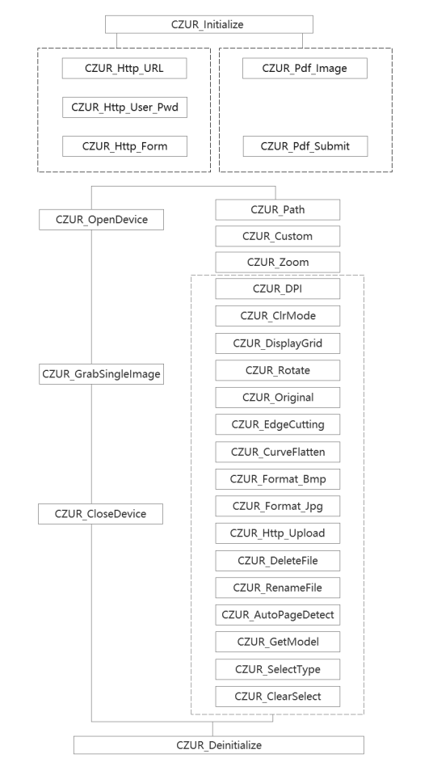

3．Manual Function

Manual selection added since V 1.3.0.0. Users can select scanning area manually in the preview window. Images will be cropped based on proportion of selected area.

Left click may cancel it.

*Note: Manual selection prioritizes other processing (smart cropping, Flattening Curve). Rotating will cancel previous selection and it needs to select again.*

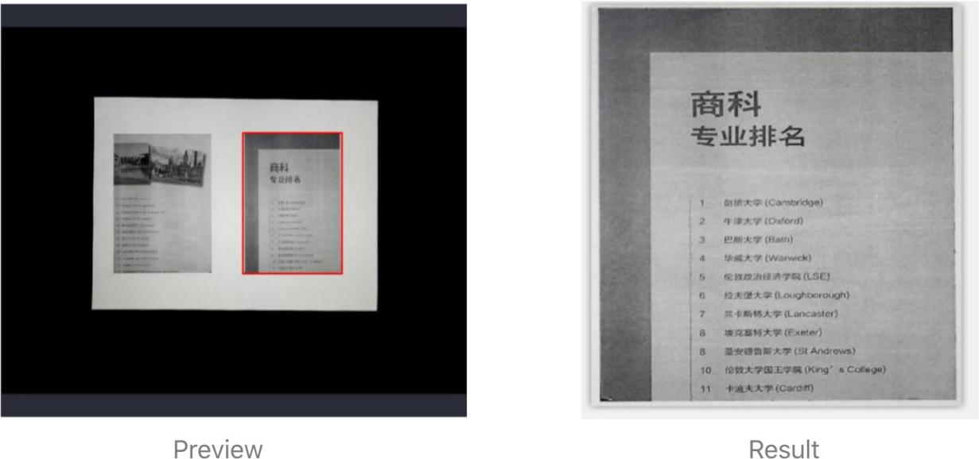

Manual selection area supports scan code added since V 1.8.0.0. Users can select scanning area by mouse manually in the preview window, images will be cropped based on proportion of selected area, and then recognize the bar code or QR code.

Left click may cancel it.

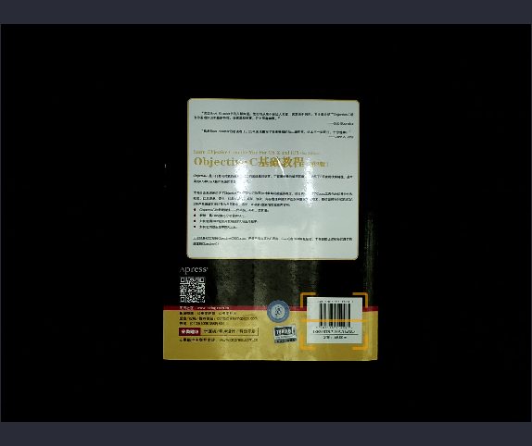

1. Function Explanation

|  |  |  |
| --- | --- | --- |
| long CZUR_EdgeDetect(long detect) | | |
| Function | Enable EdgeDetect or not | |
| Parameters | detect | 0: Unable EdgeDetect ;  1: Enable EdgeDetect |
| Return value | - | |
|  | | |
| long CZUR_GetXPosition() | | |
| Function | Get the X coordinate of the valid display area for the EtOcxEx . | |
| Parameters | - | |
| Return value | X coordinate | |
|  |  | |
| long CZUR_GetYPosition() | | |
| Function | Get the Y coordinate of the valid display area for the EtOcxEx | |
| Parameters | - | |
| Return value | Y coordinate | |
|  | | |
| long CZUR_GetWidth() | | |
| Function | Get the width of the valid display area for the EtOcxEx | |
| Parameters | - | |
| Return value | Width | |
|  | | |
| long CZUR_GetHeight() | | |
| Function | Get the Height of the valid display area for the EtOcxEx | |
| Parameters | - | |
| Return value | Height | |
|  | | |
| void CZUR_DisplayRect(long display, long x, long x, long width, long height, long thick, long red, long green, long blue) | | |
| Function | Display rectangular box or not | |
| Parameters | display | 0: Do not display；1:Display |
| x | The upper left corner of the rectangular box X coordinate |
| y | The upper left corner of the rectangular box Y coordinate |
| width | The width of rectangle box |
| height | The height of rectangle box |
| thick | The thickness of rectangle box |
| red | RGB red component |
| green | RGB green component |
| blue | RGB blue component |
| Return value | - | |
| Explanation | x、y、width、height can be ensure and adjust by CZUR_GetXPosition()、CZUR_GetYPosition()、CZUR_GetWidth()、CZUR_GetHeight(). | |
|  | | |
| void CZUR_DisplayText(long display, BSTR bsrText, long x, long x, long size, long red, long green, long blue) | | |
| Function | Display the reminder text or not. | |
| Parameters | Display | 0: Do not display the text;  1: Display the text |
| x | Display position X coordinate |
| y | Display position Y coordinate |
| size | Text size |
| red | RGB red component |
| green | RGB green component |
| blue | RGB blue component |
| Return value | - | |
| Explanation | x、y coordinate can be ensure and adjust by CZUR_GetXPosition()、CZUR_GetYPosition(). | |

|  |  |  |
| --- | --- | --- |
| long CZUR_Initialize(LPDISPATCH lpDispatch, BSTR bsrOCXLog) | | |
| Function | Non-JS calling interface | |
| Parameters | lpDispatch | lpDispatch interfacepointer |
| bsrOCXLog | log file name：Ocx.log(e.g.) |
| Return value | -1：Device model is not available 0 ： Failed  1 ： Success | |
| long CZUR_Initialize_V2(BSTR bsrOCXLog) | | |
| Function | Initialize EtOcxEx | |
| Parameters | bsrOCXLog | log file name：Ocx.log(e.g.) |
| Return value | -1：Device model is not available 0 ： Failed  1 ： Success | |
| Explanation | When calling successfully, uploading images, http, combing PDF will be noticed to caller as Event.   1. VC++, Delphi: CZUR_Initialize_V2 is recommended to call. See VC++, Delphi example. 2. JavaScript: CZUR_Initialize_JS is recommended to call. See JS example. 3. C#: CZUR_Initialize is recommended to call. See CZUR_Initialize example. | |

|  |  |  |
| --- | --- | --- |
|  | | |
| long CZUR_Initialize_JS(BSTR bsrOCXLog) | | |
| Function | JS calling interface | |
| Parameters | bsrOCXLog | log file name：JSOcx.log（e.g.) |
| Return value | -1：Device model is not available 0： Failed  1： Success | |
| void CZUR_Deinitialize() | | |
| Function | Clear EtOcxEx | |
| Parameters | - | |
| Return value | - | |
|  | | |
| long CZUR_GetModel() | | |
| Function | Obtain model number | |
| Parameters | - | |
| Return value | 3. F9 model  Non-3： other model | |
|  | | |
| void CZUR_Http_URL(BSTR bsrURL, BSTR bsrName) | | |
| Function | url, name of http uploading settings | |
| Parameters | bsrURL | Uploaded url |
|  | bsrName | Name property |
| Return value | - | |
| Explanation | Uploading http via Form Name: | |

|  |  |  |
| --- | --- | --- |
|  | | |
| void CZUR_Http_User_Pwd(BSTR bsrUserName, BSTR bsrPassword) | | |
| Function | User name and password settings of http uploading | |
| Parameters | bsrUserName | User name |
|  | bsrPassword | Password |
| Return value | - |  |
| Explanation | If user name and password are not required when uploading, there is no need of this interface. | |
|  | | |
| void CZUR_Http_Form(BSTR bsrName, BSTR bsrContent) | | |
| Function | Other properties setting of Form | |
| Parameters | bsrName | http upload, the name of the attribute in the form |
|  | bsrContent | http upload, the contents of the form attributes |
| Return value | - | |
| Explanation | Some properties can be called based on users’ demand.  E.g. Assign coder and type’s property, content is Jack and ET separately. | |

|  |  |
| --- | --- |
|  | |
| long CZUR_OpenDevice() | |
| Function | Open scanner |
| Parameters | - |
| Return value | 1. - Failed 2. - Successful |
|  | |
| long CZUR_CloseDevice() | |
| Function | Close scanner |
| Parameters | - |
| Return value | 1. - Failed 2. - Successful |
|  | |
| long CZUR_GrabSingleImage() | |

|  |  |  |
| --- | --- | --- |
| Function | Trigger to take photos | |
| Parameters | - | |
| Return value | 1. - Failed 2. - Successful | |
| |  |  |  |  | | --- | --- | --- | --- | | Explanation | CZUR_CALLBACK(P1, P2, P3, P4, P5) | | | | Function | Will take pictures of the mechanism of the incident to inform the upper caller | | | Parameters | P1 | The number of uploaded files | | P2 | 1、Frame select scan code area, P2 bar code, two-dimensional code content，  2、Unselected sweep area or recognition failed, P2 is empty | | P3 | Set http upload, P3 for the http information  Not set http upload, P3 is empty | | P4 | The name of the picture file 1 | | P5 | Picture file 2 name, non-paged picture, P5 is empty | | Explanation |  | | | | |
| void CZUR_Path(BSTR bsrPath) | | |
| Function | Set images saving path | |
| Parameters | bsrPath | Saving path name |
| Return value | - | |
| Explanation | Default system public images path | |
|  | | |
| void CZUR_Custom(BSTR bsrPrefix, long iInitNumber) | | |
| Function | Customize image naming rules | |
| Parameters | bsrPrefix | Image prefix name |
| iInitNumber | Image initial number |
| Return value | - | |
| Explanation | Default prefix is image. Default initial number is 1. Naming rule: Prefix number.(format)  e.g. image1.jpg | |
|  | | |
| void CZUR_Zoom(long xResolut, long yResolut) | | |
| Function | Zoom image resolution | |
| Parameters | xResolut | horizontal resolution |

|  |  |  |
| --- | --- | --- |
|  | yResolut | vertical resolution |
| Return value | - | |
| Explanation | To ensure un-deformed imges, xResolut:yResolut = 4:3 Trimming, Flattening Curve are operated based on resolution settings.  Reference resolution： 1600 × 1200(20M)  2592 × 1944(50M)  3264 × 2448(80M)  3672 × 2754(100M)  4608 × 3456(160M，ET16)  4896 × 3672(180M，ET18)  5248 × 3936(200M，M3000)  Note：  If both xResolut and yResolut are 0, export images are in default resolution.  If neither xResolut nor yResolut is 0, set resolution will work. | |
|  | | |
| void CZUR_DPI(WORD wdpi) | | |
| Function | Set images dpi. | |
| Parameters | wdpi | Image DPI |
| Return value | - | |
| Explanation | Default is 96 | |
|  | | |
| void CZUR_ClrMode(long iClrMode) | | |
| Function | Set images mode. | |

|  |  |  |
| --- | --- | --- |
| Parameters | iClrMode | 1. No mode 2. Color 3. Patterns 3- Stamps   4-Black&White 5-Grayscale |
| Return value | - | |
| Explanation | Default is 0. | |
|  | | |
| void CZUR_DisplayGrid(long lDisplayGrid) | | |
| Function | Set gridlines display | |
| Parameters | lDisplayGrid | |
| Return value | - | 1. hide 2. display |
| Explanation | Default is 0. | |
|  | | |
| void CZUR_Rotate(long iAngle) | | |
| Function | Rotate images | |
| Parameters | iAngle | 0- no rotation  90- 90° clockwise rotation  180-180° clockwise rotation  270-270° clockwise rotation |
| Return value | - | |
| Explanation | Default is 0. | |
|  | | |

|  |  |  |
| --- | --- | --- |
| void CZUR_Original() | | |
| Function | No processing(for images), including trimming and flatten | |
| Parameters | - | |
| Return value | - | |
| Explanation | Default property | |
|  | | |
| void CZUR_EdgeCutting() | | |
| Function | Automatic image trimming | |
| Parameters | - | |
| Return value | - | |
|  | | |
| void CZUR_CurveFlatten(long lSlpit) | | |
| Function | Flattening Curve | |
| Parameters | lSlpit | 0- Flatten, without paging 1- Flatten and paging |
| Return value | - | |
| Explanation | Split pages:  Left - prefix number_left.jpg Right- prefix number_right.jpg | |
|  | | |
| void CZUR_Format_Bmp() | | |
| Function | Set images into bmp format | |
| Parameters | - | |
| Return value | - | |
|  | | |

|  |  |  |
| --- | --- | --- |
| void CZUR_Format_Jpg(long iQuality) | | |
| Function | Set images into jpg format | |
| Parameters | iQuality | jpg quality： 0-100 |
| Return value | - | |
| Explanation | Default quality is 70. |  |
|  | | |
| long CZUR_Http_Upload(BSTR bsrLocalFile, BSTR bsrUrl, BSTR bsrName, BSTR bsrUserName, BSTR bsrPassword) | | |
| Function | Upload documents via http. | |
| Parameters | bsrLocalFile | Local file name |
| bsrUrl | URL name |
| bsrName | Property of parameters |
| bsrUserName | User name |
| bsrPassword | Password |
| Return value | 1-Uninitialised EtOcxExresource 2-Local file doesn’t exist  3-Failed  0-Succeed | |

|  |  |  |  |
| --- | --- | --- | --- |
| Explanation | Note:  1) If http doesn’t require user name and password, bsrUserName、barPassword pass on null value.  2) If return 0/3, it represents uploading item is failed/succeeded to upload queue, and is waiting to upload.  3) When finished, call CZUR_UPLOAD_CALLBACK to inform upper caller.  4) Explanation of name property | | |
| CZUR_UPLOAD_CALLBACK(P1, P2, P3, P4) | | |
| Function | Reverse back uploading information to application | |
| Parameters | P1 | 0 - Fail to upload;  1- Upload  succeeded. |
| P2 | Local file name |
| P3 | Error code |
| P4 | Error information |
| Explanation | P3>=200, http error code; P4 is reversed back information by server.  P3 < 200, not error code，P4 is null. Note: CZUR_CALLBACK should return immediately and avoid time-consuming  operations. | |
|  | | | |
| long CZUR_Pdf_Image(BSTR bsrImageFile) | | | |
| Function | Add images to form PDF | | |
| Parameters | bsrImageFile | Image file name (e.g. d:\image.jpg) | |

|  |  |  |
| --- | --- | --- |
| Return value | 1. - Failed 2. - Successful | |
| Explanation | Image format | Extension name |
| JPEG | jpg, jpeg |
| PNG | png |
|  | | |
| long CZUR_Pdf_Submit(BSTR bsrPdfFile) | | |
| Function | Form added document into PDF | |
| Parameters | bsrPdfFile | Formed PDF file name (e.g. d:\1.pdf) |
| Return value | 1. - Failed 2. - Successful | |
| Explanation | Forming PDF file can be time-consuming. When the called interface returns successfully, it just sends forming task to control. Calling back function to inform upper program can complete forming.  Non-JS: CZUR_PDF_CALLBACK is provided within COM object passed by calling CZUR_Initialize() interface.  JS: There is CZUR_PDF_CALLBACK methods on page. | |
| CZUR_PDF_CALLBACK(P) | |
| Function | Return formed PDF to upper program. |
| Parameters | P 0: Successfully formed  1: Fail to form |
|  | | |
| void CZUR_AutoPageDetect(long lAutoDetect) | | |
| Function | To detect page turning and trigger taking photos | |
| Parameters | lAutoDetect | 1: Detect page turning 0: No detect |

|  |  |  |
| --- | --- | --- |
| Return value | - | |
|  | | |
| long CZUR_DeleteFile(BSTR bsrFileName) | | |
| Function | Delete local documents | |
| Parameters | bsrFileName | Local file name: D:\1.jpg(e.g.) |
| Return value | 1. - Failed 2. - Successful | |
|  | | |
| long CZUR_RenameFile(BSTR bsrSrcFile, BSTR bsrDstFile) | | |
| Function | Rename local documents | |
| Parameters | bsrSrcFile | Source files name: D:\src.jpg(e.g.) |
| bsrDstFile | Destination name: D:\dst.jpg(e.g.) |
| Return value | 1. - Failed 2. - Successful | |
| Explanation | If source file name is d:\src.jpg, and destination name is d:\dst.jpg, then d:\src.jpg is renamed as dst.jpg. | |

|  |  |  |
| --- | --- | --- |
|  | | |
| void CZUR_SelectType(long lType) | | |
| Function | Set the SelectType | |
| Parameters | lType | 1: Crop Area；2: Scan code area |
| Return value | - | |
|  | | |
| void CZUR_ClearSelect(long lClear) | | |
| Function | ClearSelect area | |
| Parameters | lClear | 1：Crop area  2：Scan code area  3：All area  3：全部区域 |
| Return value | - | |
|  | | |
| void CZUR_BlankPageDetect(long lBlankDetect) | | |
| Function | Blank Page detection | |
| Parameters | lBlankDetect | 0: Unable blank page detection  1: Enable blank page detection |
| Return value | - | |
| Explanation | Unable blank page detection as default.  To use blank page detection correctly,please set crop edges and  flatten the pages[see also CZUR_EdgeCutting()、CZUR_CurveFlatten()] | |